## Lab - Hazard and Operability Analysis

**Objectives:**

Demonstrate the ability to perform a guideword based HazOp on a simplified chemical process system.

## Instructions

Develop a HazOp Analysis document using the Excel HazOp Template provided.

1. The system should be divided into reasonable nodes with realistic deviations and consequences recorded.
2. Select one node from the system and complete the HazOp worksheet for all reasonable deviations within that node.
3. Evaluate the risk and recommend possible risk treatment techniques (be specific).
4. Identify the IRMI and FMRI based he MIL-STD 882 risk matrix.

**Lab HazOp Report Deliverables**

* Modified Process Flow Diagrams P&ID drawing with all node boundaries identified
* HazOp Worksheet with appropriate assessment of at least one system Nodes, Parameters, Guidewords and Deviations in a single Excel Spreadsheet
  + Risk Matrix Assessment for each deviation
  + Corrective Action Recommendations for each deviation
  + References
    - You may be required to use references other than our text or the Fire Protection Handbook for this analysis. Attach a bibliography in a tab in the worksheet

**Vinyl Chloride Monomer Production**

Cowboy Chemicals has decided to pursue development of a *Vinyl Chloride Monomer* Project**.** Several recommendations identified in the PHAs have been implemented in the detailed design.

Your System Safety Consulting team will perform a Hazard and Operability study on the chemical process system described below. HazOp worksheets should be generated using the Excel spreadsheet provided

The basic process one line diagram for Vinyl Chloride is as shown below and the final layout of process flows is also included.

**For purposes of the simplified HAZOP assume a control valve and flow, temperature and pressure sensors between each process vessel and a level sensor within columns and storage vessels.**

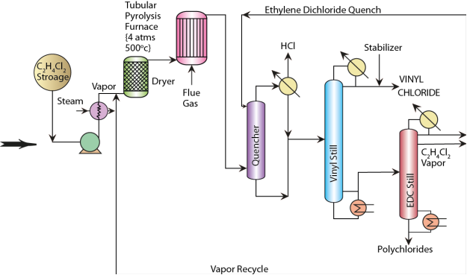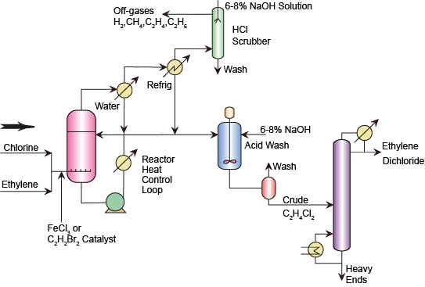



E Ethylene Dichloride (EDC) Production

* C2H4 + Cl2 → C2H4Cl2 + HEAT

|  |  |
| --- | --- |
| **Materials List** | |
| **Ethylene** | Water |
| **Chlorine** | Light hydrocarbons |
| **Ethylene Dichloride** | Heavy Hydrocarbons |
| **Vinyl Chloride Monomer** | Natural Gas |
| **Hydrogen Chloride** | **Propane** |
| **Sodium Hydroxide** | **Iron Chloride** |

|  |  |  |  |
| --- | --- | --- | --- |
| **Equipment List** | | | |
| **Equipment** | **Number** | **Chemical(s)** | **Volume** |
| **Liquid Phase Reactor** | 1 | Chlorine, Ethylene | Large (liq.) |
| **Tubular Pyrolysis Furnace** | 1 | Ethylene DiChloride, | Large (gas) |
| **Compressor** | 1 | Ethylene | Medium (gas) |
| **Storage Spheres** | 4 | EDC, VCM | Large (liq) |
| Storage Tank | 1 | HCl Acid | Large (liq) |
| **Distillation Columns** | 4 | EDC, VCM, HCl  Light and Heavy Hydrocarbons | Large (liq./gas) |
| **Accumulators** | TBD | EDC, VCM, HCl | Medium (gas) |
| **Quenching Tower** | 1 | EDC, VCM | Medium (gas) |
| **Incinerator/Scrubber** | 1 | Mixture | Medium (gas) |

# Final Site Plan

Highway to Payne Center (10 miles) East

Main Railroad Line

Cross arms and lights

Streambed Usually dry

VCM & EDC

Storage Spheres

HCl

N

VCM

Plant (New)

Effluent pond

property line

Existing Chlorine Plant

EDC feed System

Maintenance Building (future)

Parking

Administrative Offices

Cimarron River

**Community Response Capability Information:**

* + Payne Center has a small paid Fire Department
    - 1 Engine company
    - 1 ambulance
  + Cowboy Corners has a 50-bed hospital with an Emergency Room, 15 miles from the plant site.
  + Cowboy Corners has a volunteer Fire Department
  + Cowboy Corners and the surrounding area is served by a private ambulance service with 2 ambulances in service and one stand-by ambulance
  + Site potable water is from a rural water system. Process water is taken from the river and purified in a treatment plant